# EXPERIMENT NO. 2

# Aim:

To study and practice GIT commands for version control.

# Theory:

**Git** is one of the most popular version control systems. It is a distributed version control system. Changes do not have to be committed to the same central repository, which would require that every person working on the project to access that central repository and download the latest code in order to save changes.

Some of the basic operations in Git are:

1. Initialize
2. Add
3. Commit
4. Pull
5. Push

Some advanced Git operations are:

1. Branching
2. Merging
3. Rebasing

The following diagram depict the all supported operations in GIT

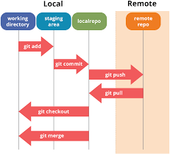

Installation of GIT

1. In windows, download GIT from https://git-scm.com/ and perform the

straightforward installation.

1. In Ubuntu, install GIT using $sudo apt install git,

Confirm the version after installation $git --version

Once installation is done, open the terminal in Ubuntu and perform the following steps or in

windows Right click and select Git bash here.

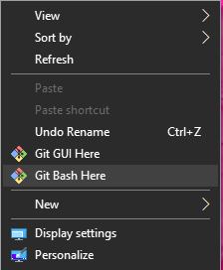

Version Control

To perform version control, let us create a directory dvcs (Distributed version control system)

and change directory to dvcs.

$ mkdir git-dvcs

$ cd git-dvcs/

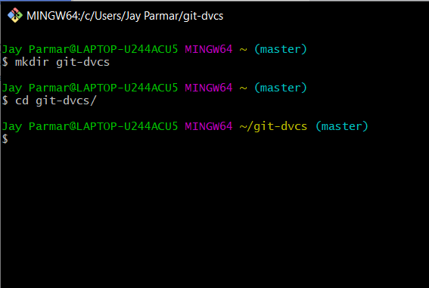

Now check the user information using

$ git config –-global

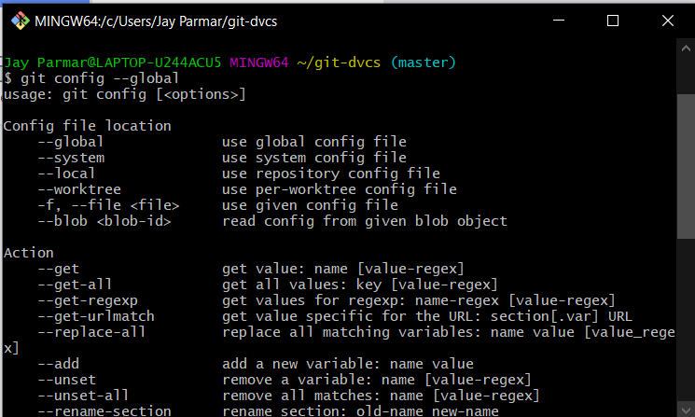

As there are no users defined, let us define it using following two commands

$ git config --global user.name "jay-2000"

$ git config --global user.email “jayparmar7654321@gmail.com”

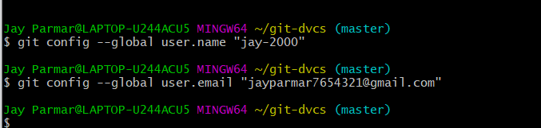

Now, check the list of users

$ git config --global –list

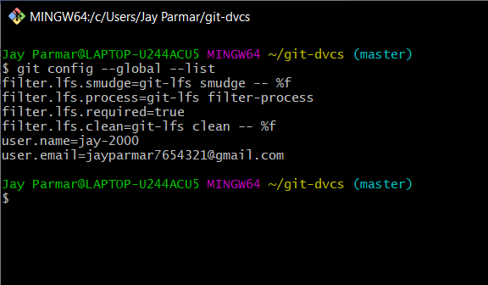

Let us create a repository for version control named ”git- demo-project”

$ mkdir git-demo-project

$ cd git-demo-project/

Now, initialize the repository using following command

$ git init

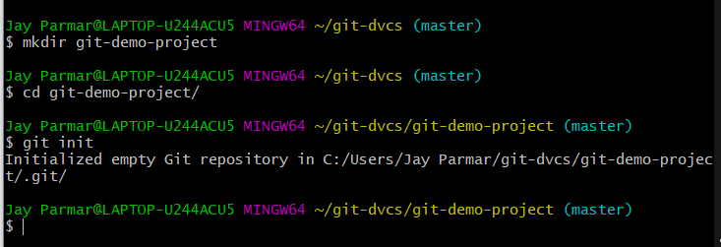

Now, let us add some files inside our repository “git-demo- project”

To add files in index and staging area, add command is used along with dot (. Dot means

current directory)

$ git add .

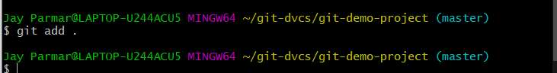

Index and staging area

To check the status of repository, use

$ git status

Which will show you some untrack files, so untracks files can be tracked using commit command.

Now, let us commit the changes

$ git commit -m "First Commit" (#here -m for message)

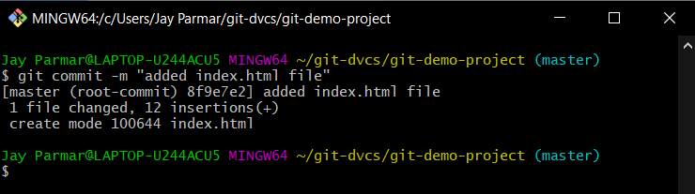

Added index.html in our directory

$ touch teststatus

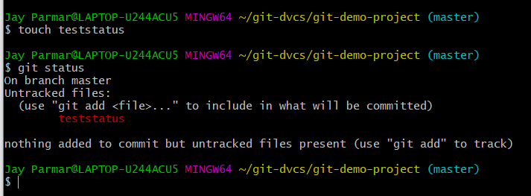

History of Commits

$ git log

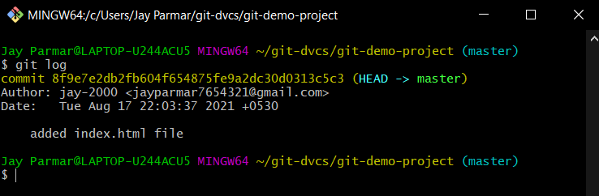

Now Create a Repository on github.com. Open github.com→ create an account→After login

Select New repository from the menu.

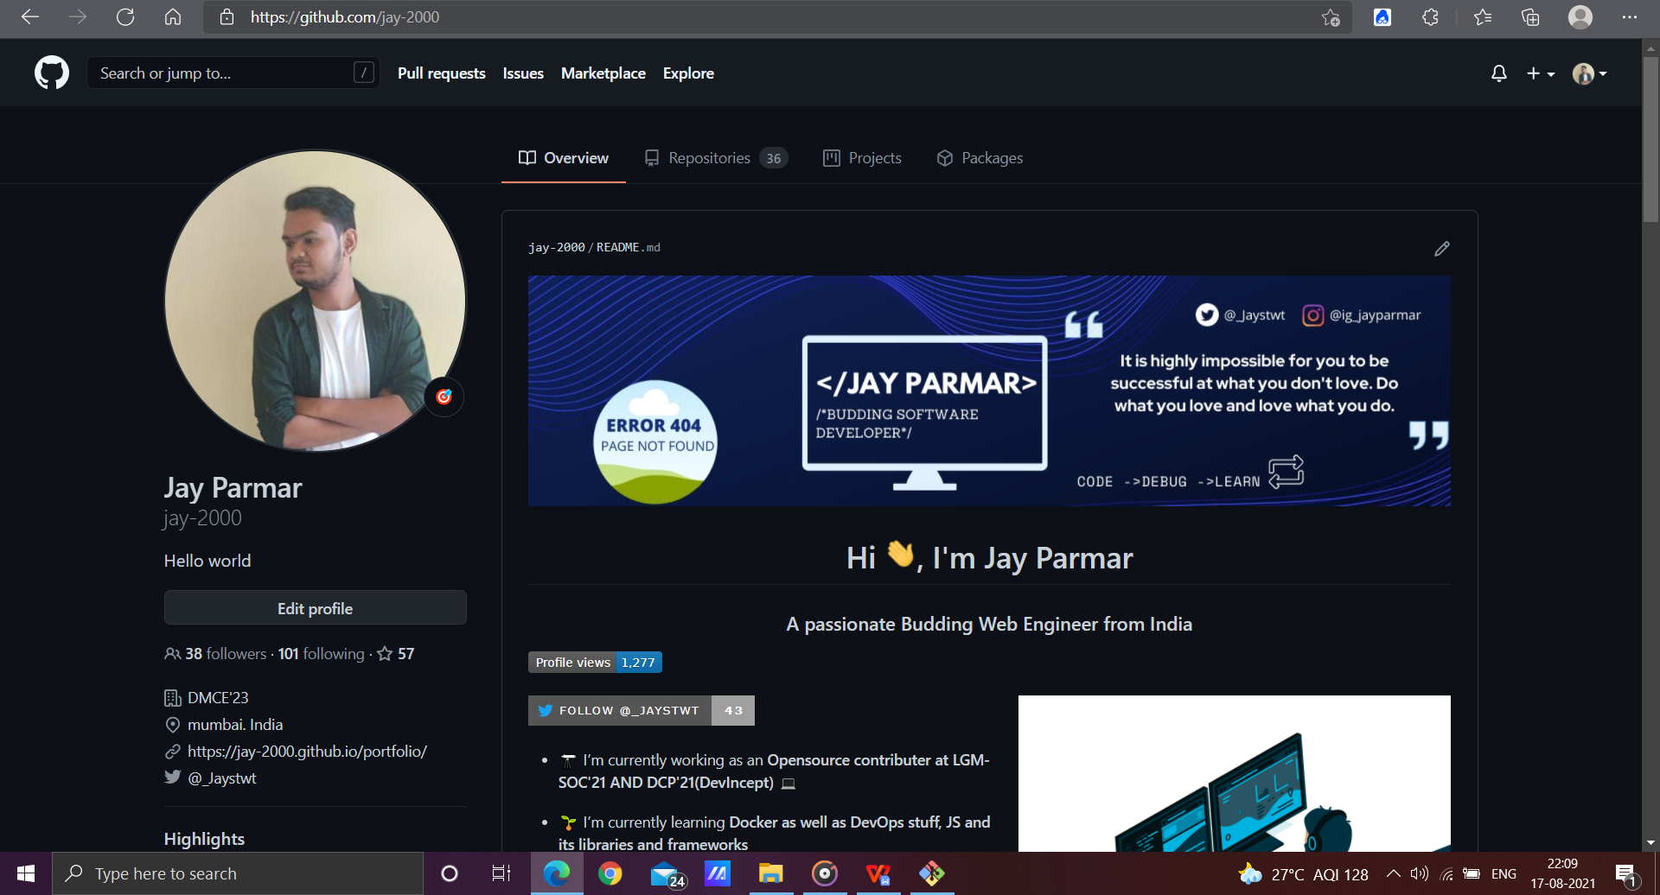

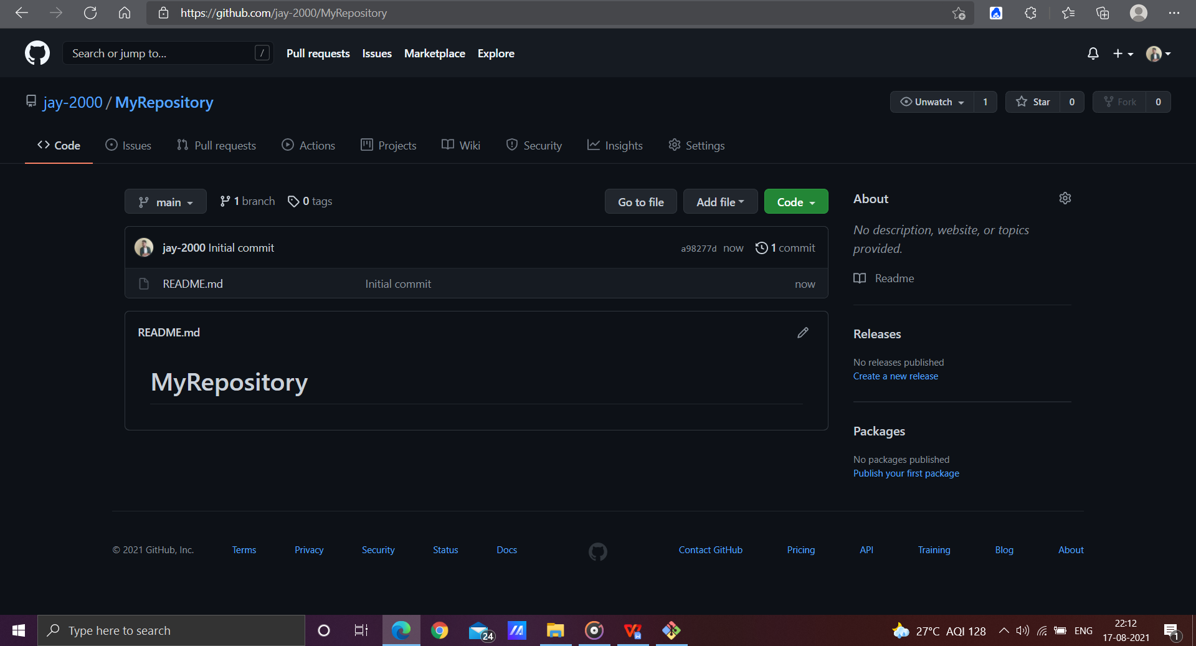

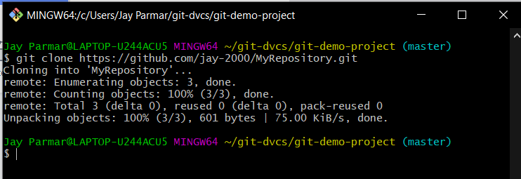

Now fork the repository (Sharing with other users who wants to contribute).

Login with another account→Copy and Paste URL of repository→then just click on fork to clone

to others account.

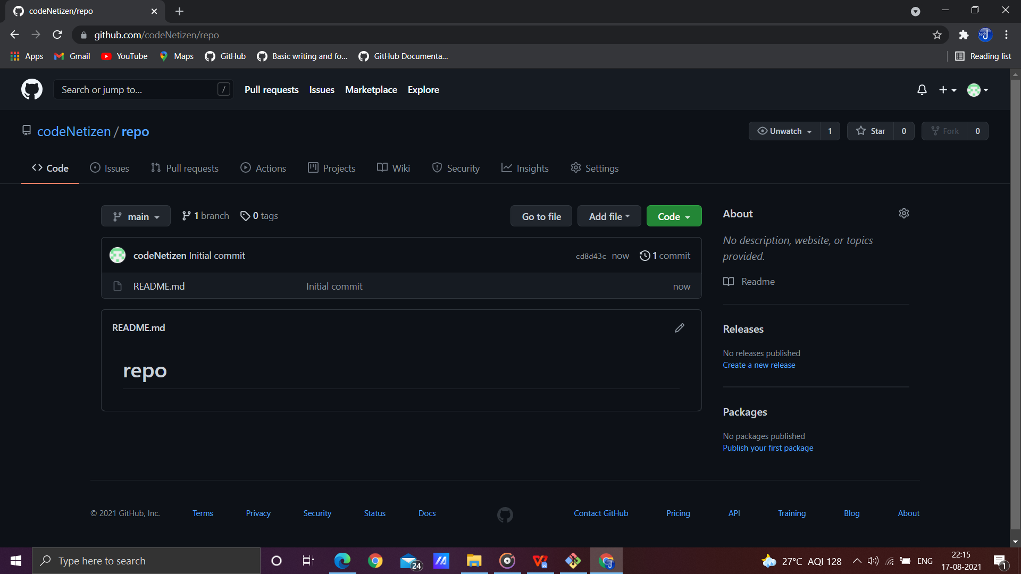

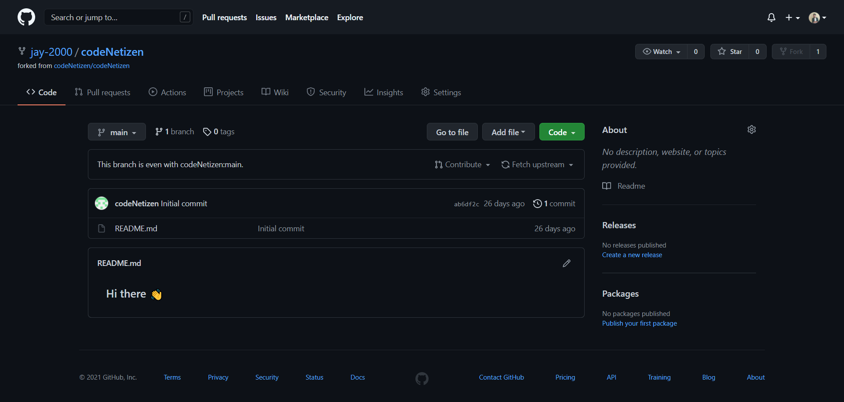

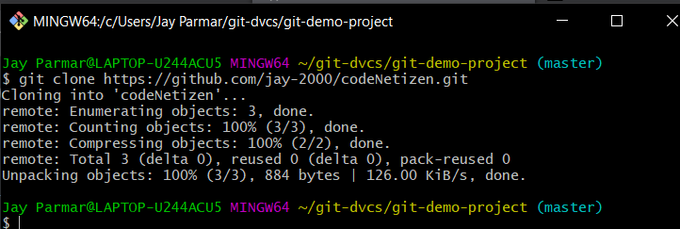

Pull and Push Processes

Push → Push changes to Web repository Pull → Pull changes to Local repository

* 1. Push command to remote reference origin master

$ git remote add origin https://github.com/bhushanjadhav1/siesworkshop.git

$ git remote show origin

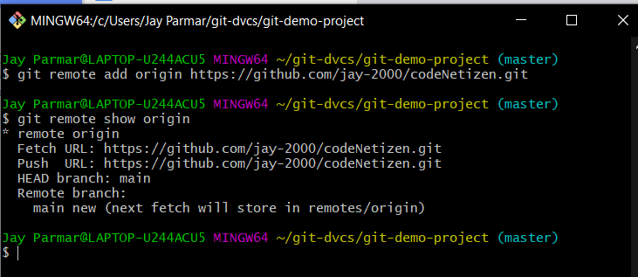

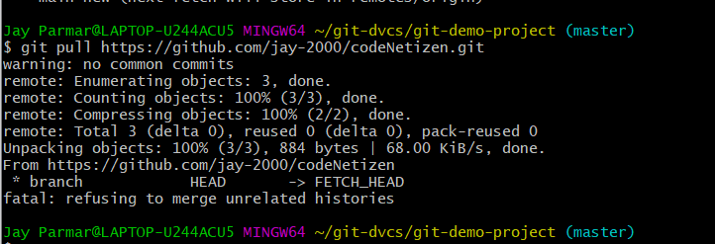

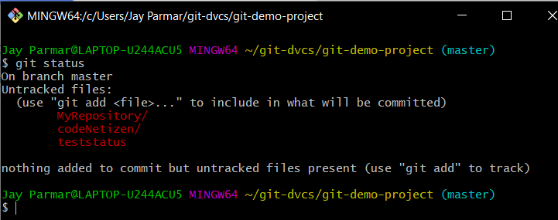

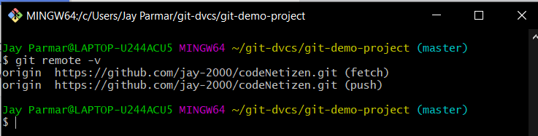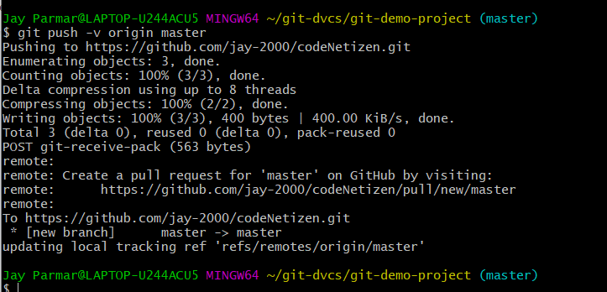

$ git pull

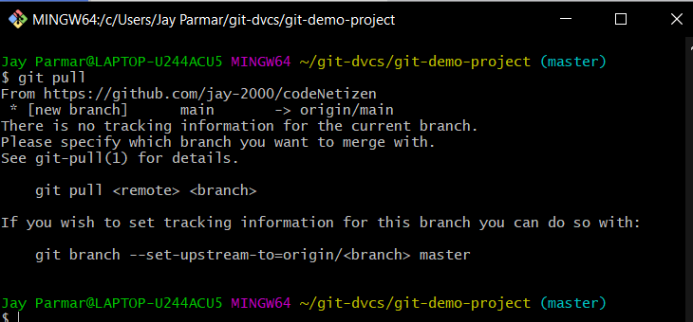

Conclusion:

Hence studied and practiced GIT commands for version control.